Milestone 1 - Advanced Excel and SQL – Salary Data Analysis
- Rohinth Shanmugasundaram
- DADS, August Batch B

Introduction:

The Motive of the project is to do data cleaning through the help of Excel and aggregate data with the help of SQL, building pivot tables and dashboards with the help of advanced excel functions.

Dataset Overview:

- Age Range: The age group of the individual.
- Industry: The sector or field in which the individual works.
- Job Title: The official title of the individual’s position.
- Clarification of Job Title: Additional context or details about the job title.
- Annual Salary: The individual's annual salary or earnings.
- Additional Monetary Compensation: Extra earnings beyond the base salary (e.g., bonuses, commissions).
- Currency: The currency in which the salary and compensation are reported.
- Other Currency: A custom currency if it doesn't match the standard options.
- Income Clarification: Additional context regarding the income structure (e.g., commission-based).
- Country: The country where the individual works.
- State: The state or province where the individual works (if applicable).
- City: The city where the individual works.
- Years of Professional Experience Overall: The total number of years the individual has worked professionally.
- Years of Professional Experience in Field: The number of years the individual has worked in their specific field.
- Highest Level of Education Completed: The highest degree or educational level attained by the individual.
- Gender: The gender identity of the individual.

Data Cleaning and Pre Processing:
Removing Duplicates:
There were 151 duplicates in the dataset, they were removed with the help of “Remove Duplicates” function in the Excel.
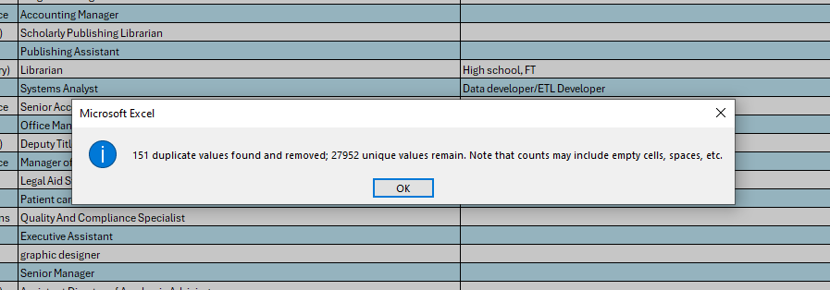
Removing Columns:
Removing columns that are having higher missing value percentages. For example, the columns – ‘Clarification of Job title’, ‘Other Currency’, ‘Income Clarification’ have missing values more than 50 percentage hence those columns were deleted from the dataset.
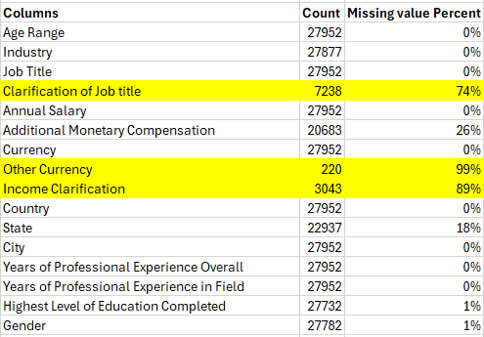
Removing Rows:
There are anomalies present in each of the columns – to present cleanest part for data analysis – removing such rows.
For Example, as seen above the column – ‘Job Title’ have hyphens and irrelevant titles like ‘mum’ so those rows are removed.
The column city should have texts but it contains – numbers and hyphens, so such rows are removed.
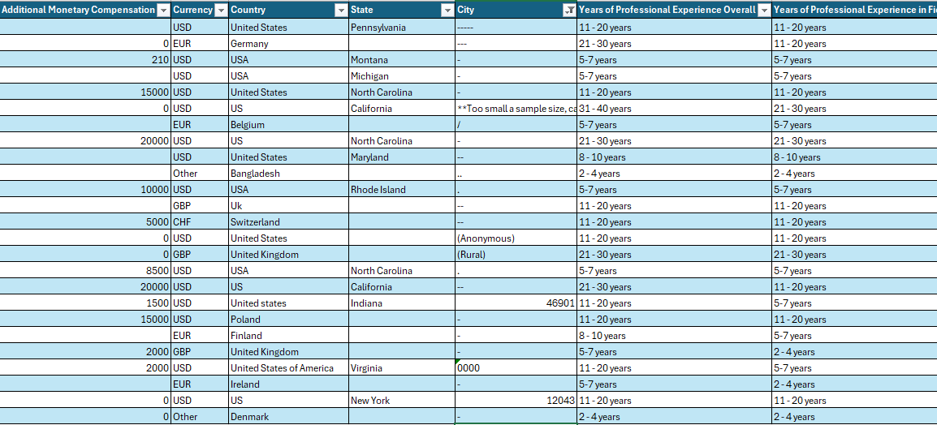

Some anomalies were present in countries – removing such rows.

Data Interpolation:
The column country has different variation of each county names – for example the country – United States have variations like, USA, US, us and states. Lot of such variations were present irrespective of the case. So, filtering them and making them consistent with respect to the wording’s spacings and cases.
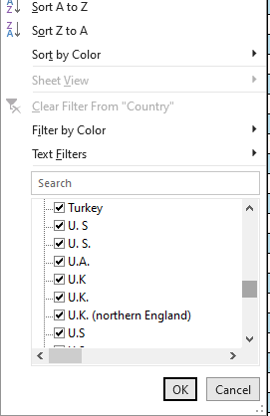
The same thing happened in currency were for New Zealand and Australia had similar currency like AUD/NZD, so they were filtered and AUD is replaced for Australia and NZD is replaced for New Zealand.
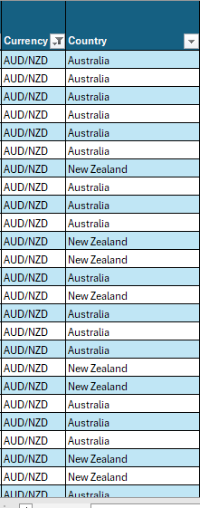
Preprocessing:
To go through with the analysis especially aggregating data based on salary – it is important for us to make the currencies similar, hence USA is the most popular country in the dataset so changing every other currency with the conversion formula,
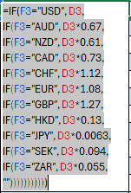

Changing the format:
The dataset, particularly the cleaned dataset is converted into a csv file to upload it in SQL.

SQL Query:
- The dataset is further uploaded in a database called World and the data is imported.
- Each of the queries have been applied and the results are exported as a csv files.
- It is made sure that the data is not limited for the results.
Mentioning two such queries
Query 1
select avg (`Annual Salary in USD`) as avg_salary, Industry, Gender
from salaryanalysis
group by Industry, Gender;

Here the query is aggregated for annual salary and is grouped for the categories Industry and gender.

Query 2
SELECT Gender, ROUND (100.0 * SUM (CASE WHEN `Additional Monetary Compensation in USD` > 0 THEN 1 ELSE 0 END) / COUNT (*),2) AS percentage_of_add_comp
FROM salaryanalysis
GROUP BY Gender;

Here in the query, when the compensation is greater than zero it is counted and interpolated to 1 or else zero, these ones are counted to analyze them as percentages of compensation across gender.
Advanced Excel Analysis:
Relationships:
Making Relationships with different tables with primary and foreign keys.
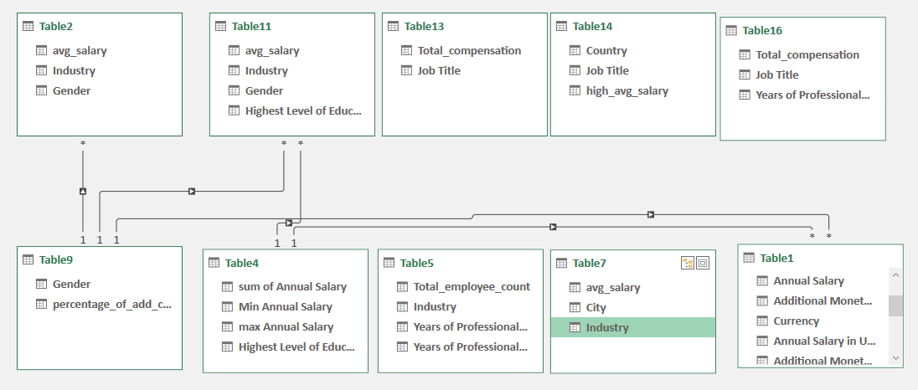
The columns are queried, and now they don’t belong to the same data table, so relationships must formed, so that pivot tables, charts and slicers can be connected and the dashboard can be interactive and visually appealing.
For Example, the table with gender and percentage of people that had add compensation, has unique gender data so they can form one to many relations with relevant tables.
Pivot Tables and charts:
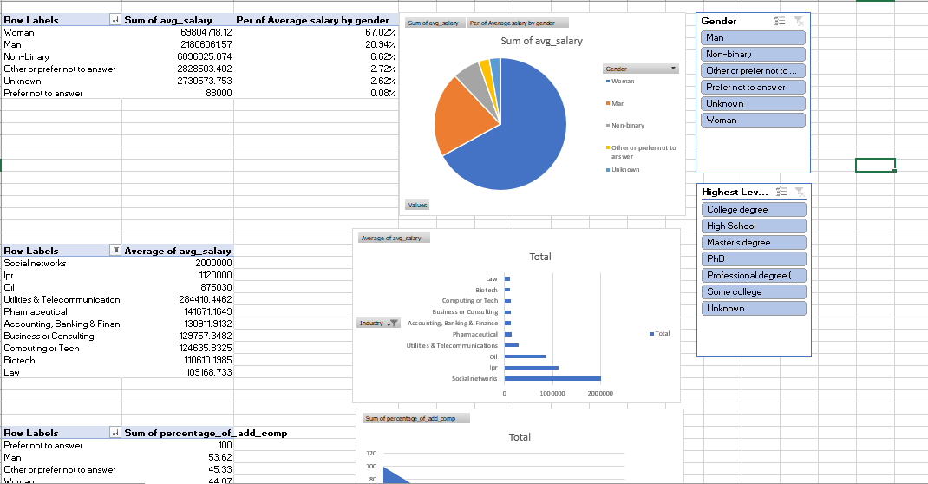
These Tables are created through power pivot, they were formed from the connected tables only, so that the final result can be interactive.
Finally – The slicers will be connected with all the pivot tables analyzed.
Dashboard:
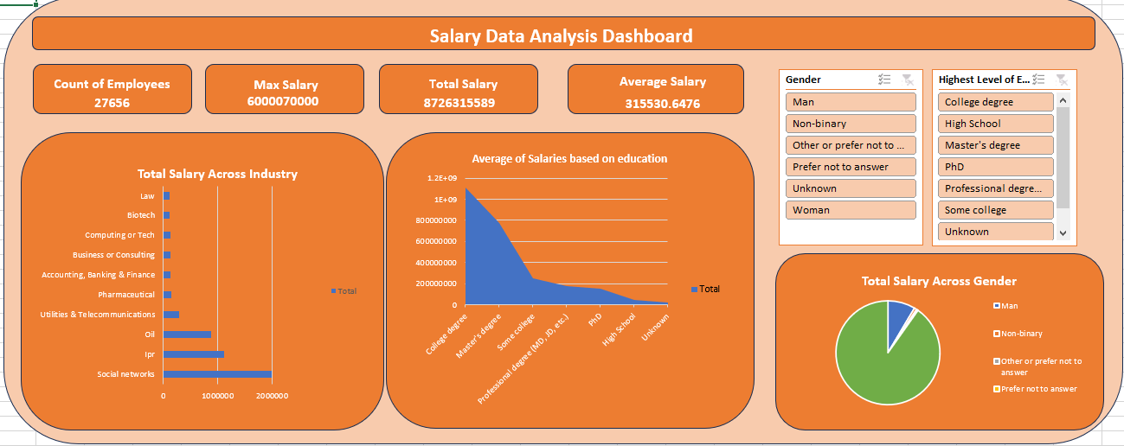
The dashboard is created by aligning all the charts and slicers and key performance indicators are prepared from the main cleaned table so that we will get the whole picture of the data and its behavior.
Insights:
- The peoples with highest levels of education – like PHD and professional degree have higher annual average salary of about 120 thousand dollars per annum.
- The trend seems to increase for master’s degree which is above 80 thousand dollars per annum.
- Social Network as an industry have contributed around about 2 million dollars a year.
- IPR – The Intellectual Property Right provides salary of more than 1 million dollars.
- PHD being the highest average salary – slicing it women contribute about 65 percent in that salary.
- Men have performed very well in utilities and telecommunication industry having average salary greater than 160 thousand dollars
- Women have performed very well in IPR industry with the average salary of below 120 thousand dollars.
Recommendations:
- From the above insights we could say that people with higher levels of education, have higher salary, so people those who need improved salary range should constantly upskill themselves.
- Social Networks, IQR and Oil have been recognized as fields with high potential based on the above data, so persons who would consider reliability and job security can consider entering those fields.
- Women have especially performed well in IQR industry, so encouraging especially students to explore such industry.
- men have especially performed well in utilities and telecommunication industry, so encouraging especially students to explore such industry.
Conclusion:
In Conclusion I have used Excel to clean and preprocess the data, then employed SQL to query for different aggregations based on different columns, the created relations of such tables with power pivot in excel, created pivot tables and dashboards for insights and recommendations.

